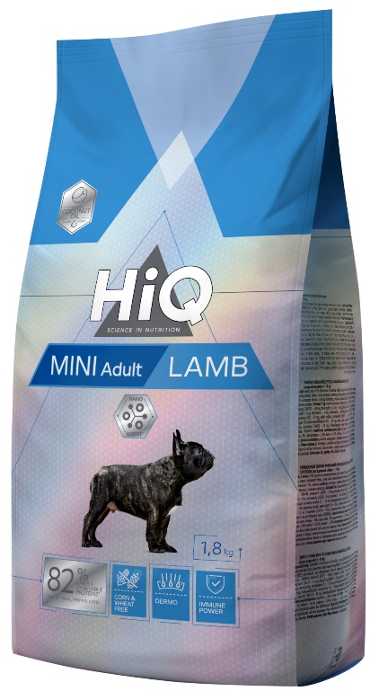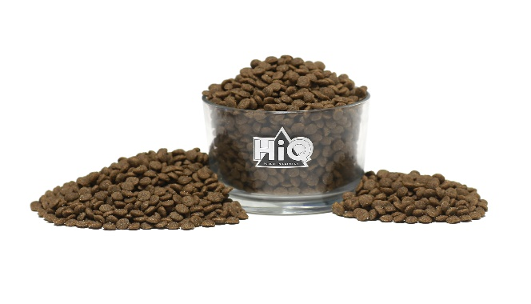

Mini Adult Lamb

FOR ADULT DOGS OF SMALL (1–10 KG) BREEDS. FORMULA WITH LAMB

• With lamb protein to meet nutritional needs and maintain energy balance.
• Contains no wheat and corn, so it is suitable for gluten sensitive dogs with sensitive digestive system.
• Healthy skin and thick and shiny coat.
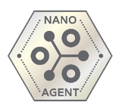

NANO AGENT
HiQ feeds are supplemented with an exceptional ingredient – NanoAgent. It is a natural mineral processed to nanoparticles. Due to the light weight of nanoparticles, NanoAgent moves faster through a pet‘s body than various nutrients do. When in contact with NanoAgent they also start to move around faster which leads to better digestion and more efficient absorption of nutrients.

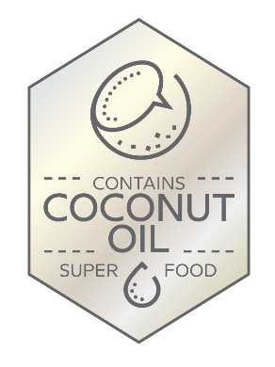

COCONUT OIL
HiQ feeds for adult pets are enriched with one of the most valuable products in the world – natural and beneficial, pure coconut oil, also know as one of the few superfoods. It may optimize pet‘s metabolic processes and improve the condition of digestive tract. Pure coconut oil also positively affects skin and coat and may help to protect against infections and diseases. Due to its ability to stimulate brain activity, this component is especially beneficial for pets of senior age.

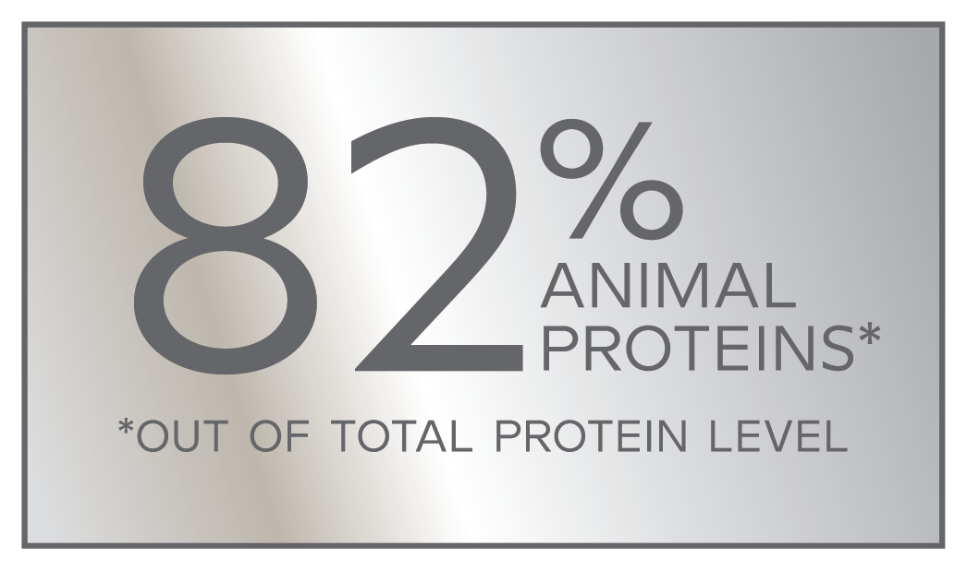

82% ANIMAL PROTEINS
With high quality lamb protein - to optimize the energy balance and ensure nutritional needs. In addition, protein from animal sources ensure and maintain the proper amount of amino acids, that are crucial for every dog’s and cat’s healthy and long life.

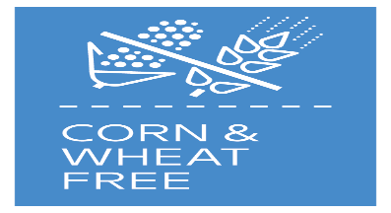

CORN & WHEAT FREE
Understanding the problems of dogs with extremely sensitive digestive system, we have created and included in HiQ line the corn and wheat free feeds. These may help dogs with sensitive skin and stomach avoid allergic reactions caused by wheat gluten and ensure perfect digestion for those which do not tolerate corn.
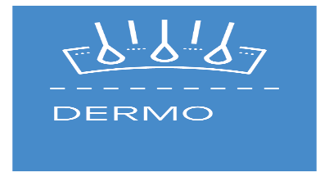

DERMO
Polyunsaturated fatty acids are essential for your pet, as they can help to maintain shiny and thick coat as well as healthy and elastic skin. A complex of zinc and vitamins (vit. C, E, A, B) promotes synthesis of keratin, which is one of the most important element ensuring healthy structure of feet, skin and coat.
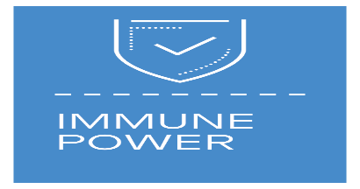

IMMUNE POWER
Exclusive complex of vitamins with valuable lipids maintains and supports immune protection of tissues and cells.

COMPOSITION:
lamb meat 41% (dried and finely ground), rice, barley, poultry fat, potato protein, sugar beet pulp, peas, pea protein, linseed, coconut oil, brewer’s yeast, dynamic micronized clinoptilolite (1%), monosodium phosphate, chicory extract, mannano-oligosaccharides (MOS), yucca extract, yeasts (beta-glucans), marigold dried.

ADDITIVES/1 KG:
Nutritional additives: vitamin A (3a672a) – 18000 IU, vitamin D3(E671) – 1500 IU, vitamin E (3a700) – 530 mg, folic acid (3a316) – 1 mg, biotin (3a880) – 0,2 mg, niacin (3a314) – 35 mg, vitamin B6 (3a831) – 3 mg, vitamin B1– 3 mg, vitamin B12– 0,05 mg, choline chloride (3a890) – 1480 mg, ferrous sulphate monohydrate (E1) – 50 mg, calcium iodate anhydrous (3b202) – 1,5 mg, cupric sulphate pentahydrate (E4) – 5 mg, manganous sulphate monohydrate (E5) – 20 mg, zinc sulphate monohydrate (3b605) – 115 mg, sodium selenite (E8) – 0,1 mg, L-carnitine (3a910) – 50 mg.
Technological additives: rosemary extract, tocopherol extracts from vegetable oils (1b306(i)).

ANALYTICAL CONSTITUENTS:
crude protein – 28%, crude oils and fats – 16%, crude ash – 9%, crude fibres – 2,1%, calcium – 1,5%, phosphorus – 1%, potassium – 0,5%, sodium – 0,4%, omega 3 – 0,63%, omega 6 – 2,47%.

FEEDING INSTRUCTIONS:
serve the food dry. Clean, fresh water should be available at all times.

FEEDING GUIDE:
see table. The amount presented in table are guidelines only and should be adapted according to individual dog needs.
